**Lab 1 Instructions**

Imagine a square grid of NxN rooms. Each room has doors leading to its neighboring rooms (NSEW neighbors only). One room at the edge opens to the outside world i.e. the entry point. This room also has a charging station. One room has a pot of gold in it. An agent has to start from the entry point, explore the rooms, locate the pot of gold and bring it to the entry point. There is an additional constraint. The agent is powered by a battery. The battery (on full charge) has enough charge to visit X rooms where X < N2. So, suppose the agent is currently in the room (y, z) then it has to decide whether it should explore further or return back to the entry point to recharge itself.

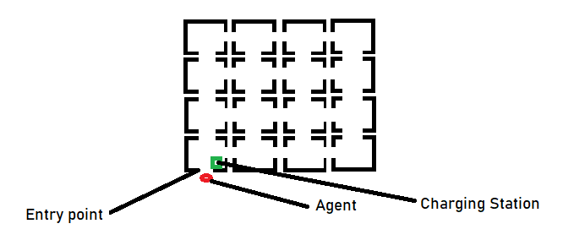

Write the agent program.

You will have to define the environment (the NxN) rooms along with the doors.

You will have to define the suitable actions that the agent would take.

You will have to update its memory (i.e. which rooms have been explored and found empty).